Internationalization
- The process of designing a web application such that it supports various countries, various languages without performing any changes in the application is called Internationalization.
- We can implement Internationalization by using the following classes. They are:
- Locale
- NumberFormat
- DateFormat
1. Locale: A Locale object can be used to represent a geographic (country) location (or) language.
- Locale class present in java.util package.
- It is a final class and direct child class of Object implements Cloneable and Serializable Interfaces.
How to create a Locale object:
- We can create a Locale object by using the following constructors of Locale class.
- Locale l=new Locale(String language);
- Locale l=new Locale(String language,String country);
- Locale class already defines some predefined Locale constants. We can use these constants directly.
Example:
Locale. UK
Locale. US
Locale. ITALY
Locale. CHINA
Important methods of Locale class:
- public static Locale getDefault()
- public static void setDefault(Locale l)
- public String getLanguage()
- public String getDisplayLanguage(Locale l)
- public String getCountry()
- public String getDisplayCountry(Locale l)
- public static String[] getISOLanguages()
- public static String[] getISOCountries()
- public static Locale[] getAvailableLocales()
Example for Locale:
import java.util.*;
class LocaleDemo{
public static void main(String args[]){
Locale l1=Locale.getDefault();
//System.out.println(l1.getCountry()+"....."+l1.getLanguage());
//System.out.println(l1.getDisplayCountry()+"....."+l1.getDisplayLanguage());
Locale l2=new Locale("pa","IN");
Locale.setDefault(l2);
String[] s3=Locale.getISOLanguages();
for(String s4:s3)
{
//System.out.print("ISO language is :");
//System.out.println(s4);
}
String[] s4=Locale.getISOCountries();
for(String s5:s4)
{
System.out.print("ISO Country is:");
System.out.println(s5);
}
Locale[] s=Locale.getAvailableLocales();
for(Locale s1:s)
{
//System.out.print("Available locales is:");
//System.out.println(s1.getDisplayCountry()+"......"+s1.getDisplayLanguage());
}}}
NumberFormat:
- Various countries follow various styles to represent number.
Example:
1,23,456.789------------INDIA
123,456.789-------------US
123.456,789-------------ITALY
- By using NumberFormat class we can format a number according to a particular Locale.
- NumberFormat class present in java.Text package and it is an abstract class.
- Hence we can’t create an object by using constructor.
NumberFormat nf=new NumberFormat(); --------invalid
Getting NumberFormat object for the default Locale:
- NumberFormat class defines the following methods for this.
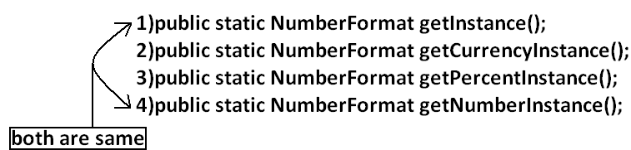
Getting NumberFormat object for the specific Locale:
- The methods are exactly same but we have to pass the corresponding Locale object as argument.
Example: public static NumberFormat getNumberInstance(Locale l);

- Once we got NumberFormat object we can call the following methods to format and parse numbers.
- public String format(long l);
- public String format(double d);
- To convert a number from java form to Locale specific form.
- public Number parse(String source)throws ParseException
- To convert from Locale specific String form to java specific form.
Example:
import java.util.*;
import java.text.*;
class NumberFormatDemo
{
public static void main(String args[]){
double d=123456.789;
NumberFormat nf=NumberFormat.getInstance(Locale.ITALY);
System.out.println("ITALY form is :"+nf.format(d));
}
}
Output:
ITALY form is :123.456,789
Requirement: Write a program to print a java number in INDIA, UK, US and ITALY currency formats.
Program:
import java.util.*;
import java.text.*;
class NumberFormatDemo
{
public static void main(String args[]){
double d=123456.789;
Locale INDIA=new Locale("pa","IN");
NumberFormat nf=NumberFormat.getCurrencyInstance(INDIA);
System.out.println("INDIA notation is :"+nf.format(d));

NumberFormat nf1=NumberFormat.getCurrencyInstance(Locale.UK);
System.out.println("UK notation is :"+nf1.format(d));
NumberFormat nf2=NumberFormat.getCurrencyInstance(Locale.US);
System.out.println("US notation is :"+nf2.format(d));
NumberFormat nf3=NumberFormat.getCurrencyInstance(Locale.ITALY);
System.out.println("ITALY notation is :"+nf3.format(d));
}}
Output:
INDIA notation is: INR 123,456.79
UK notation is: ú123,456.79
US notation is: $123,456.79
ITALY notation is: Ç 123.456,79
Setting Maximum, Minimum, Fraction and Integer digits:
- NumberFormat class defines the following methods for this purpose.
- public void setMaximumFractionDigits(int n);
- public void setMinimumFractionDigits(int n);
- public void setMaximumIntegerDigits(int n);
- public void setMinimumIntegerDigits(int n);
Example:
import java.text.*;
public class NumberFormatExample
{
public static void main(String[] args){
NumberFormat nf=NumberFormat.getInstance();
nf.setMaximumFractionDigits(3);
System.out.println(nf.format(123.4));
System.out.println(nf.format(123.4567));
nf.setMinimumFractionDigits(3);
System.out.println(nf.format(123.4));
System.out.println(nf.format(123.4567));
nf.setMaximumIntegerDigits(3);
System.out.println(nf.format(1.234));
System.out.println(nf.format(123456.789));
nf.setMinimumIntegerDigits(3);
System.out.println(nf.format(1.234));
System.out.println(nf.format(123456.789));
}}
Output:
123.4
123.457
123.400
123.457
1.234
456.789
001.234
456.789
DateFormat: Various countries follow various styles to represent Date. We can format the date according to a particular locale by using DateFormat class.
- DateFormat class present in java.text package and it is an abstract class.
Getting DateFormat object for default Locale:
- DateFormat class defines the following methods for this purpose.
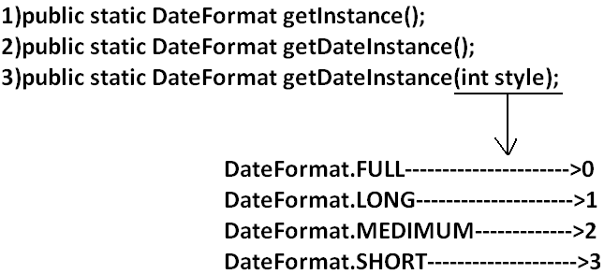
Getting DateFormat object for the specific Locale:
- public static DateFormat getDateInstance(int style, Locale l);
- Once we got DateFormat object we can format and parse Date by using the following methods.
- public String format(Date date);
- To convert the date from java form to locale specific string form.
- public Date parse(String source)throws ParseException
- To convert the date from locale specific form to java form.
Requirement: Write a program to represent current system date in all possible styles of us format.
Program:
import java.text.*;
import java.util.*;
public class DateFormatDemo
{
public static void main(String args[]){
System.out.println("full form is :"+DateFormat.getDateInstance(0).format(new Date()));
System.out.println("long form is :"+DateFormat.getDateInstance(1).format(new Date()));
System.out.println("medium form is :"+DateFormat.getDateInstance(2).format(new Date()));
System.out.println("short form is :"+DateFormat.getDateInstance(3).format(new Date()));
}
}
Output:
Full form is: Wednesday, July 20, 2011
Long form is: July 20, 2011
Medium form is: Jul 20, 2011
Short form is: 7/20/11
Note: The default style is medium style.
Requirement: Write a program to represent current system date in UK, US and ITALY styles.
Program:
import java.text.*;
import java.util.*;
public class DateFormatDemo
{
public static void main(String args[]){
DateFormat UK=DateFormat.getDateInstance(0,Locale.UK);
DateFormat US=DateFormat.getDateInstance(0,Locale.US);
DateFormat ITALY=DateFormat.getDateInstance(0,Locale.ITALY);
System.out.println("UK style is :"+UK.format(new Date()));
System.out.println("US style is :"+US.format(new Date()));
System.out.println("ITALY style is :"+ITALY.format(new Date()));
}
}
Output:
UK style is: Wednesday, 20 July 2011
US style is: Wednesday, July 20, 2011
ITALY style is: mercoled∞ 20 luglio 2011
Getting DateFormat object to get both date and time:
- DateFormat class defines the following methods for this.
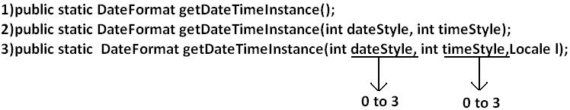
Example:
import java.text.*;
import java.util.*;
public class DateFormatDemo
{
public static void main(String args[]){
DateFormat ITALY=DateFormat.getDateTimeInstance(0,0,Locale.ITALY);
System.out.println("ITALY style is:"+ITALY.format(new Date()));
}
}
Output:
ITALY style is: mercoled∞ 20 luglio 2011 23.21.30 IST

